

11/16/2019

Anusha Seshagiri Ashrit Kulkarni Nagarjuna Kanneganti Sourabh Reddy

ISM 6136 – Data Mining

Cab Price Prediction

Data-Mining Project – Final Paper

Table of contents

**ACKNOWLEDGEMENT** 2

**Introduction** 3

**Goal and Motivation** 3

**Dataset description:** 4

**Data preprocessing:** 5

**Feature Selection** 6

**Boruta Technique:** 6

**Model Building** 8

**Results** 10

**Data Visualization** 12

**Recommendations and Considerations** 18

**Adding New Attributes :** 18

**Future Considerations:** 18

**References** 19

**ACKNOWLEDGEMENT**

In this competitive world there is a race of existence where people are having a strong will to come and succeed. Project is a proof of our theoretical learning and practical working. We would like to express our sincere gratitude to **Prof. Balaji Padmanabhan** for his invaluable guidance and support throughout the semester. We would also thank our seniors for their suggestions and references

Sincerely

Team Data Drillers

# **Introduction**

Our organization serves many software companies like Microsoft, Google and Amazon by providing assistance in data-driven decisions to improve their business significantly. In 2018, our company was established to solve business problems in an innovative way. We have started building solutions using artificial intelligence, machine learning and deep learning. We provide machine learning services to big companies to monetize our company. In this case, our company wants to find out how cab prices are varying and wants to build a good model which helps in increasing their business as well as our business by selling off that model.

In this case, our organization wants to build case, where they wanted to know which cab service is preferred and the best based on the data available.

**Goal and Motivation :**

The main goal or aim is to try to find the best machine learning model which can yield the highest accuracy in predicting the prices and surge of the cabs based on cab data obtained from Uber and Lyft share apps.

Uber and Lyft have been the top two ride sharing services in united states. They have developed their applications with niche and improved their services significantly since the advent of them. Our organization wants to know to how to increase their business of by leveraging the power of machine learning.

For achieving our goal, we decided to take an open data from Kaggle to serve our business need. This dataset is based on the past cab rides data which was collected via both these apps(Uber and Lyft). We want to use that dataset to find out what factors mainly contribute in driving the demand. In this project, we have answered few business questions that our organization wants to know by analyzing the dataset.

1. Which organization cabs do people prefer and why?
2. Which day is the busiest among the other days in a week?
3. Which brand of cabs are preferred during surge?
4. How surge is varying over long distances?
5. How climate is affecting the surge?

We believe that by answering questions posted above would give us a better idea of how the business of Uber and Lyft are changing according to various factors. By analyzing, we can recommend few ways to increase the business by careful experimentation.

## **Dataset description:**

We have collected two datasets from Kaggle to predict the price of a cab based on various factors like source, distance, timestamp and weather conditions . The first dataset doesn’t contain any personal information like name of the customer who had travelled or email or phone number of the customer. It consists of the cab rides information of Uber and Lyft organizations. This dataset is based on one-week activity of cab rides during the month of November for certain locations in Boston.

The second dataset is based upon the weather conditions like temperature, rain, cloud, snow etc. which can affect the pricing of a cab.

This dataset consists of 24 variables and they are tabulated as follows.

|  |  |  |  |
| --- | --- | --- | --- |
| **S.No** | **Variable** | **Type** | **Description** |
| 1 | distance | Float | Distance of the ride (in miles) |
| 2 | cab_type | String | Specifies the ride sharing company (Uber or Lyft) |
| 3 | destination | String | Destination of the ride |
| 4 | source | String | Source location of the ride |
| 5 | price | Float | Fare for the ride (in dollars) |
| 6 | surge_multiplier | Float | Surge multiplier of the price |
| 7 | name | String | Specifies the type of the cab as sedan or XL or Luxury |
| 8 | time | String | Time of the data taken |
| 9 | date | Date | Specifies the date of the ride |
| 10 | hour | Integer | Specifies the hour of the ride |
| 11 | minute | Float | Specifies the minutes of the ride |
| 12 | seconds | Float | Specifies the seconds of the ride |
| 13 | day | String | Specifies the day of the ride |
| 14 | temp_avg | Float | Temperature during the ride in Fahrenheit |
| 15 | clouds_avg | Float | Concentration of clouds |
| 16 | pressure_avg | Float | Pressure during the ride in mb |
| 17 | rain_avg | Float | Rain fall during the ride in inches |
| 18 | humidity_avg | Float | Humidity during the ride in % |
| 19 | wind_avg | Float | Wind measurement during the ride |

## **Data preprocessing:**

We have used R Programming language to pre-process the given data. In this project we have two data sets, one has cab ride details and the other has weather details.

* As a first step of pre-processing, the timestamp in both the data sets is converted from epoch time to the eastern time zone as the data is collected for Boston city.
* Then from the eastern time format in both the data sets, we extracted the day, time in hours, minutes.
* In the cab rides data set, for some instances, the price values are missing. The missing values are removed from the data set.
* The weather data set has some missing values in the rain column. These missing values are replaced with the median of the rolling window of size 5.
* Rolling window functions impute the missing values and help to avoid inconsistency in the data.
* A new column called merge is added in both datasets. Merge column has location and date so that based on that column, the data sets can be merged.
* The required columns from weather data set have been selected and then both the data sets are merged into a single data set on which machine learning models can be built to predict price and surge-multiplier values from the given dataset.
* After using the Boruta feature selection technique, we have found some columns that do not impact the dataset and those columns have been removed from the merged data set.

# **Feature Selection**

## **Boruta Technique:**

Since there are many attributes and data points in the dataset we need to optimize and extract the useful information from the high-volume data. For that we have used a statistical technique called “Boruta”, which randomizes the columns through permuting data points and comparing original attributes’ with the permuted attributes to find the most important features eliminating the irrelevant ones.

After running the “Boruta” function, we found that the following columns have to be removed from the dataset for better performance of a model on the dataset as they are irrelevant ones

**‘merge’**

**‘time_stamp’**

**‘id’**

**‘product_id’**

**‘newtime’**

**‘minute’**

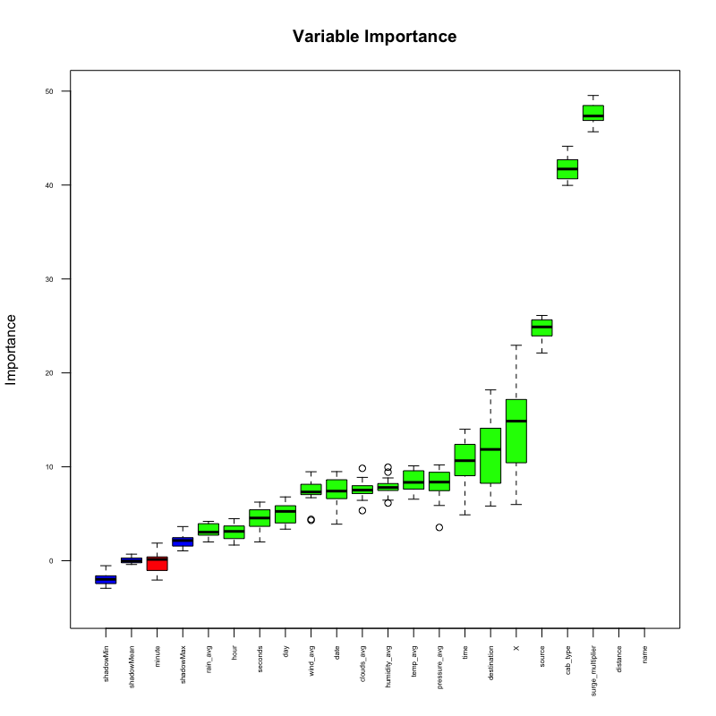

# **Model Building**

**Microsoft Azure ML models**

For selecting the best model for prediction, we have chosen 5 different models to understand the behavior of the models on the dataset. We then compared the 5 models to find the best fit model.

Steps followed:

* The columns for prediction are considered using column selector
* The data set has been split into 70:30 where 70% is for training and 30% is for testing
* For training the model we used “price” column as output for the prediction of cab prices and “surge_multiplier” for the prediction of surge
* The Azure Machine Learning models are built on the merged data set which has details of cab rides and weather conditions during those rides
* We ran different regression models on the merged data set to compare and see which regression model gives the better outcome

In this experiment, we compare the following models in regression:

* **Bayesian Linear Regression**
* **Neural Network Regression**
* **Boosted Decision Tree Regression**
* **Linear Regression**
* **Decision Forest Regression**

For all models, we use the **Train Model** module to train the model; then we use the **Score Model** module to make the prediction on the test data set; based on the prediction on the test data set, we apply the **Evaluate Model** module to compute the regression performance for different models.

For **Bayesian Linear Regression** and **Decision Forest Regression**, the output of **Evaluate Model** consists of the following 6 metrics:

1. Negative Log Likelihood
2. Mean Absolute Error
3. Root Mean Squared Error
4. Relative Absolute Error
5. Relative Squared Error
6. Coefficient of Determination

For **Neural Network Regression**, **Boosted Decision Tree Regression**, and **Linear Regression**, the negative log likelihood is not computed, so only 5 metrics are computed.

**Combining Multiple Regression Performance Metrics**

We combine and compare all regression performance metrics together by using the **Execute R Script** and **Add Rows** modules. The **Evaluate Model** module produces a table with a single row that contains various metrics. In the **Execute R Script** module, we extract the regression performance metrics and add the corresponding model name manually. The R code in **Execute R Script** for the **Bayesian Linear Regression** model is

dataset <- maml.mapInputPort(1)

# Add algorithm name into the data frame

data.set <- data.frame(Algorithm='Bayesian Linear Regression')

data.set <- cbind(data.set, dataset[2:6])

maml.mapOutputPort("data.set");

Note that we ignore the negative log likelihood and extract the remaining 5 metrics.

For **Neural Network Regression**, **Boosted Decision Tree Regression**, and **Linear Regression** models, we add the model name and extract all metrics. The following is the R code in the **Execute R Script** for **Linear Regression**:

dataset <- maml.mapInputPort(1)

# Add algorithm name into the data frame

data.set <- data.frame(Algorithm='Linear Regression')

data.set <- cbind(data.set, dataset[1:5])

maml.mapOutputPort("data.set");

All **Execute R Script** modules in this experiment produce a table with a single row that contains model name and various metrics. Finally we use the several **Add Rows** modules to combine all regression performance metrics together.

**Results**

The final results of the experiment for **price prediction**, obtained by right-clicking the Results data set output of the last **Add Rows** are:

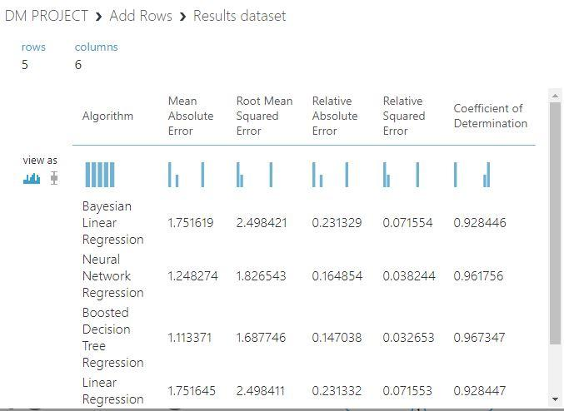

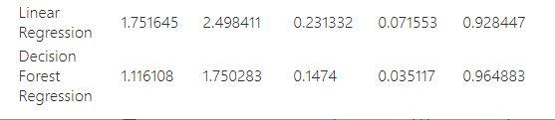

The final results of the experiment for **surge multiplier**, obtained by right-clicking the Results data set output of the last **Add Rows** are:

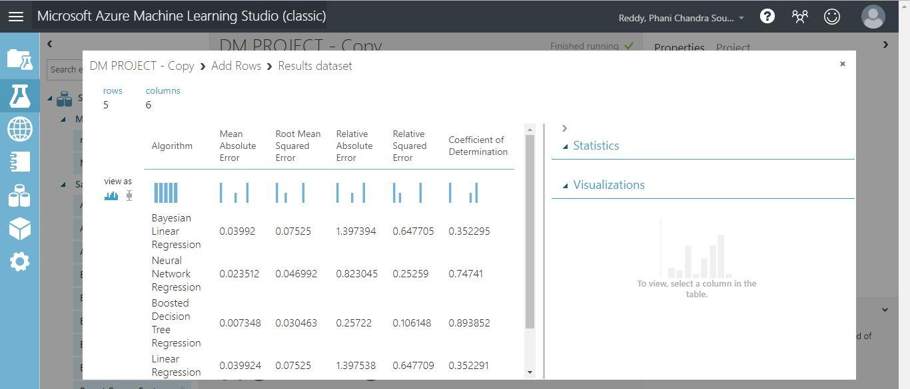

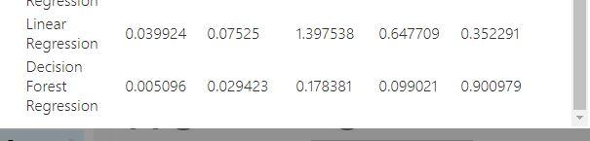

Taking Coefficient of Determination as our validation metrics we got the following results

**Cab Price Prediction:** For Cab Price prediction **“*Boosted Decision Tree Regression***” model has outperformed other models since the score of Coefficient of Determination is **96.73%**. Also the Mean absolute error score is **1.11** which is very less compared to other outcomes

**Surge_Multiplier Prediction:** For Surge_Multiplier prediction **“*Decision Forest Regression*”** model has better Coefficient of Determination score which is **90.01%.**

## **Data Visualization**

We visualized correlation of the attributes in the data by drawing plots between different attributes using R Programming.



* A plot has been drawn between the distance and surge_multiplier to analyze whether distance has an impact on surge_multiplier or not.
* From the above plot, we can visualize that only the Lyft cab rides have surge_multiplier prices.
* We can see that surge_multipliers do not have any significance for Uber cab rides.



* A Plot has been drawn between distance and price to analyze and compare how the prices are varying with distance for the two share ride apps.
* We can visualize from the above data set, the density of Uber cabs is more relatively when compared to Lyft.
* More Uber cabs are available for longer distances.

* A plot has been drawn between day and surge_multiplier to analyze how surge_multiplier varies based on which week of the day.
* As we visualized from the previous plot, that Uber doesn’t have a surge_multiplier, we can visualize that for the Lyft cabs , the highest surge rate is almost on every day of the week except for Friday.



* A plot has been drawn for a random day in the week of November to analyze how the price variable is varying based on the time of the day for each of Lyft and Uber cab rides.
* We can visualize that the Lyft has the highest price during 11 AM.
* We can visualize that most of the rides fall in between the morning hours from 5 AM – 9 AM and in between the evening hours 5 PM – 10 PM.

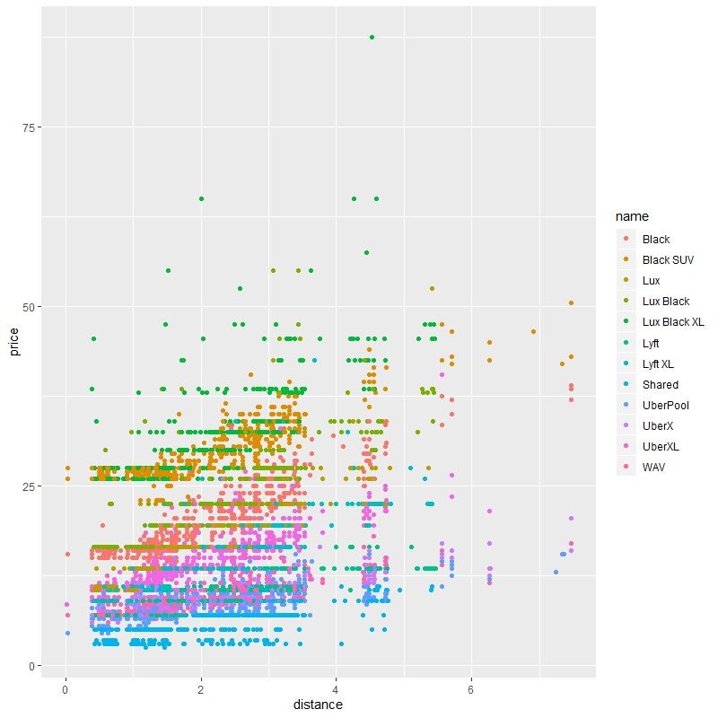

* We have drawn a plot to analyze how the prices vary for different car models based on the distance.
* As expected, the prices are higher for the Luxury cabs.
* They are the least for Uber Pool, Shared Cab types.

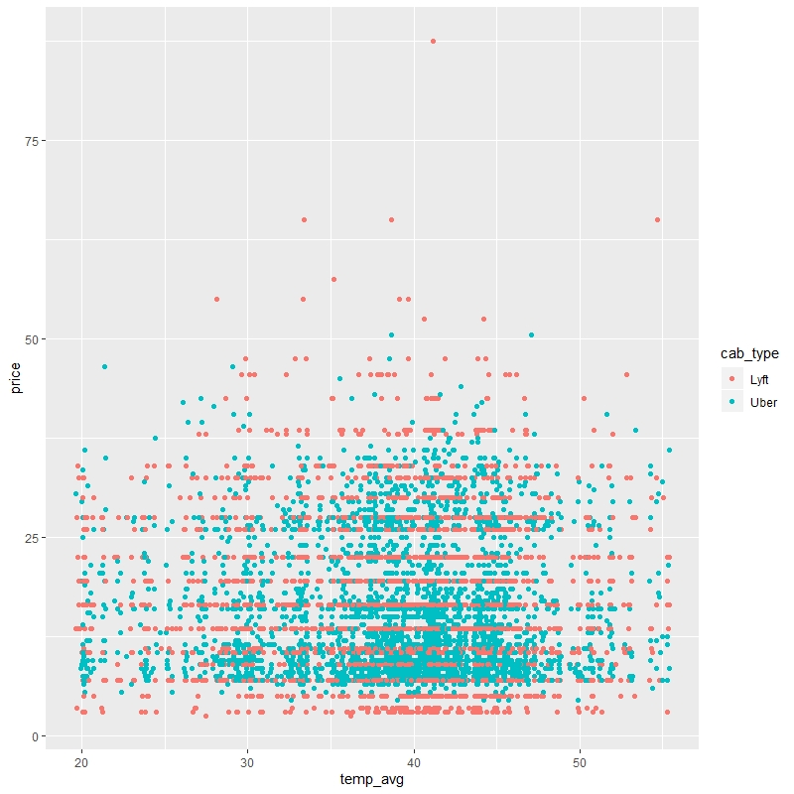

* A plot has been drawn between temperature and price to predict how the price gets impacted based on the temperature.
* Through the above data plot, we are not able to visualize how the temperature is affecting the price accurately .

# **Recommendations and Considerations**

## **Adding New Attributes :**

Few other attributes like the total time travelled, number of dropping points could also be considered for better prediction of the prices.

The total time travelled includes the waiting time, traffic etc. Taking these factors into consideration, will give the better accuracy of the model.

## **Future Considerations:**

Also, once we deploy the model in an app, users can get a real-time basis cab price and probable chances of surge for future times. This can help regular users’ pre-book the cab for future timing based on the predictions.

# **References**

Compare models and selecting the relevant columns for comparison

<https://gallery.azure.ai/Experiment/f35e1ba8a0a34ccd9ce2dc0758de34cb>

Boruta Technique in brief

<https://www.datacamp.com/community/tutorials/feature-selection-R-boruta>

Data Set

<https://www.kaggle.com/c/new-york-city-taxi-fare-prediction>